**DUE DATE**: 16-12-2024

**MANAGEMENT SCIENCES**

**BBA**

* PROGRAMMING LANGUAGE FOR BUSINESS ANALYTICS
* PROJECT REPORT
* SUBMITTED TO: MAAM RABAIL ASGHAR
* SUBMITTED BY:

HADIA AMIR (FA23-BBA-049)

MUSTAFA MAIRAJ (FA23-BBA-098)

AMINA ZAHID (FA23-BBA-019)

DANIYAL NADEEM (FA23-BBA-040)

 KHAWAJA MUHAMMAD MUAZ (FA23-BBA-065)

# Departmental Store Business Analysis Project

This report presents a detailed analysis of sales performance data from a departmental store, aiming to understand factors influencing sales and revenue achievement. The project utilizes Python programming and data visualization techniques to uncover key insights and identify areas for improvement.

**Table of Contents:**

1. Project Objective
2. Dataset Overview
3. Questions Answered
4. Features Implemented:

* Data Analysis
* User Input
* Data Visualization
* Data Summarization

1. Code Structure
2. Results:

* Key Findings
* Summary Output

1. Conclusion and Future Improvements



# Project Objective

The primary objective of this project is to perform a comprehensive analysis of sales performance data from a departmental store to gain valuable insights into the factors impacting sales and revenue generation. This analysis will identify areas for improvement, enhance sales strategies, and ultimately optimize overall business performance.

## Dataset Overview

The dataset used in this project comprises transactional data from a departmental store. It includes key columns such as Branch, City, Customer type, Gender, Product line, Unit price, Quantity, Total sale, Tax 5%, Date, Time, Payment, and Rating.

Branch Branch of the store (A, B, or C)

City Location of the branch

Customer type Member or Normal customer

Gender Gender of the customer

Product line Category of products purchased

Unit price Price per unit of the product

Quantity Number of units purchased

Total sale Total transaction value

Tax 5% Tax applied to the transaction Date Date of the transaction

Time Time of the transaction

Payment Payment method used

Rating Customer satisfaction rating

## Questions Answered

1. Total sales across all branches.
2. Average sales per transaction.
3. Branch with the highest total sales.
4. Top product line by revenue.
5. Proportion of Member vs. Normal customers.
6. Total revenue by gender.
7. Most frequently used payment method.
8. Average gross margin percentage across transactions.
9. City with the highest total sales.
10. Average quantity sold per product line.
11. Average sales value of high-rating transactions (Example: rating > 8.0).
12. Total sales by each branch.
13. Peak transaction hours.
14. Tax-to-sales ratio.
15. Revenue generated for unit prices above a user-defined threshold.

Features Implemented

#### Data Analysis

Calculations were performed for each question using Python's built-in libraries like csv for file handling.

#### User Input

The program allows dynamic filtering based on user input, including:

 Sales with unit prices above a threshold.

 Transactions with ratings above a threshold.

Filtered data is saved into a new CSV file (filtered\_data.csv).

#### Data Summarization

A summary of results is written to a text file (summary.txt).

#### Data Visualization

Four graphs were generated using Matplotlib:

Line Graph: Total Sales by Branch - Shows total sales for each branch.

Line Graph: Revenue by Gender - Compares revenue contributions from male and female customers.

Bar Graph: Average Quantity Sold by Product Line - Displays the average quantity sold for each product line. Bar Graph: Payment Method Frequency - Highlights the frequency of payment methods used.

Code Structure

The code is modularized into reusable functions:

Data Loading: load\_csv ()

Data Analysis: Functions for calculations, e.g., total sales (), highest\_sales\_branch() Data Filtering: save\_filtered\_data()

Summary Generation: write\_summary()

Visualization: Functions for graph generation, e.g., plot\_branch\_sales(), plot\_gender\_revenue()

Results

### Key Findings

1. Branch C had the highest total sales, followed by Branch A and Branch B.
2. Health and Beauty was the top product line in terms of revenue.
3. Male customers contributed slightly more to revenue than female customers.
4. E-Wallet was the most frequently used payment method.
5. The highest number of transactions occurred during peak hours around midday.

### Summary Output

The following summary was written to summary.txt

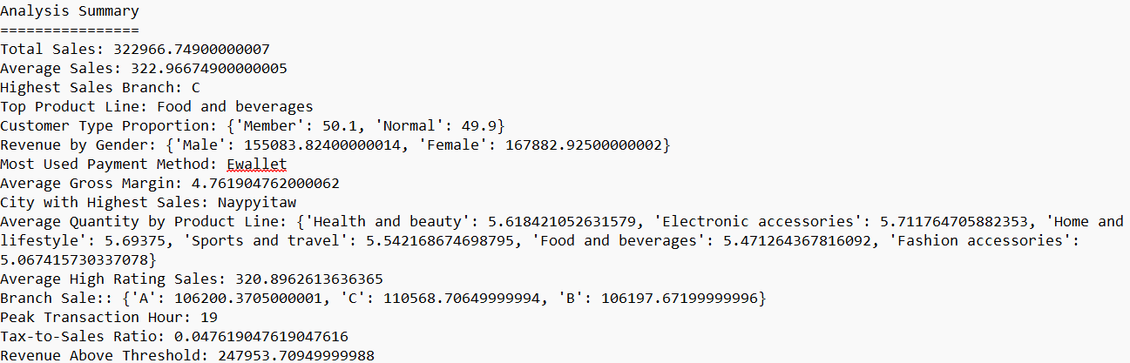

# Conclusion and Future Improvements

This project successfully demonstrated the practical application of Python programming in business analytics, providing actionable insights into branch performance, customer preferences, and product trends. The modular code structure ensures reusability and adaptability for future datasets.

Future improvements include using pandas for more efficient data manipulation, incorporating advanced visualizations (e.g., heatmaps, pie charts), automating user report generation in PDF format, and conducting additional analysis, such as customer segmentation and trend forecasting.

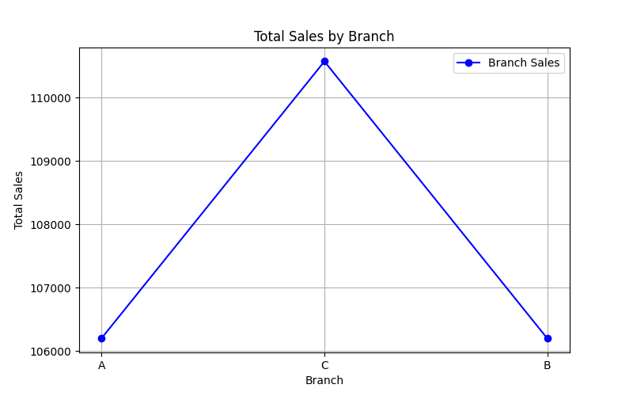 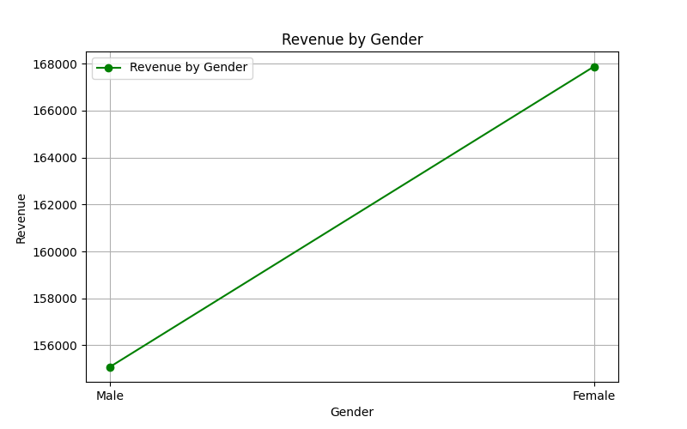

Line Graph: Total Sales by Branch Line Graph: Revenue by Gender

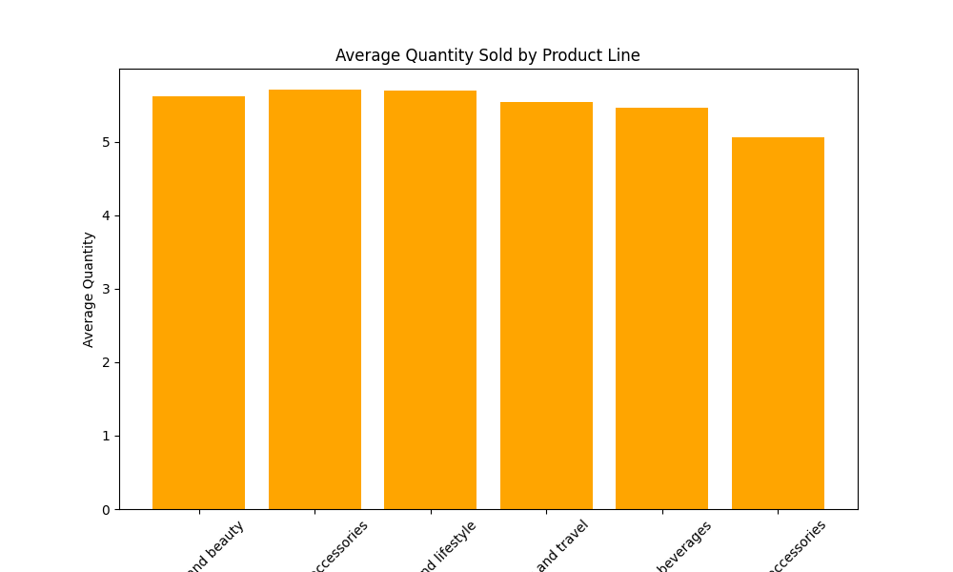 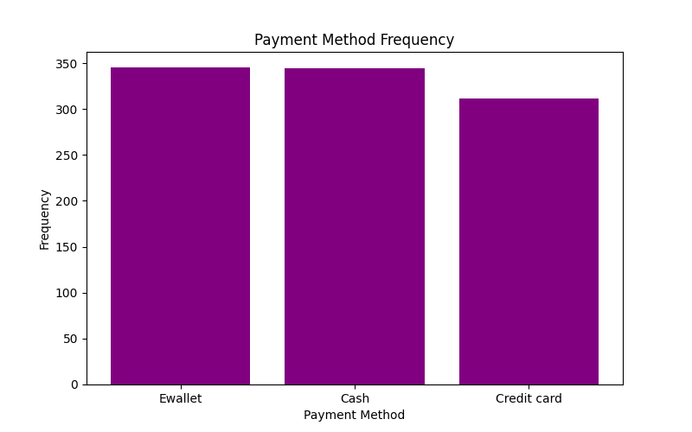

Bar Graph: Average Quantity Sold by Product Line Bar Graph: Payment Method Frequency